The Deaf & Blind Among Us
June 16, 2016

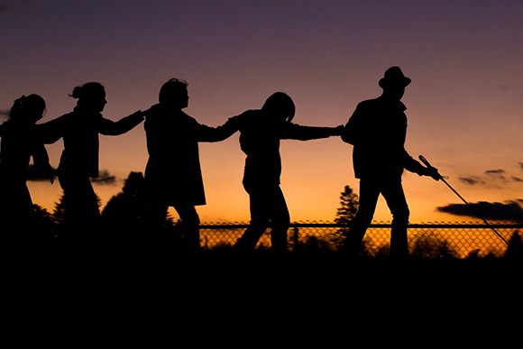
The blessing of Jesus, His endless patience and love be with you all. When I read your comments Heartdwellers, I marvel at your love for one another. Truly, God is with us, the fruit is so sweet on this channel, thanks to your good hearts. I beg for His patience, and humility and brotherly love in my trials. And pray that you, too, will be blessed with these qualities.

Jesus…what do you have for us tonight?

He answered, "My Love. My sadness. My sorrow. My contending with the deaf and blind. What you are suffering with one, I have and am suffering with millions. I have called, but they are taken up with the world and tuned into it’s frequency. You were like this once…and if My hand was off of you, you’d be right back there again.

"Aren’t you glad My hand is on you?"

You know I am, Lord. You know I am. And yes, I am no better. In fact, considering all the graces you’ve given me, I am the worst sinner of all.

He answered, "See what I can do with the worst sinner of all?"

Miracles?

"Miracle after miracle after miracle.

"Yes, it is tiring to call and call and see no result worthy of all the graces expended. You are very blessed on this channel, because I have drawn like-minded and like-hearted souls into this ministry. My Dear, Dear Brides, I consider Myself extremely blessed by My Creation because you love Me and are willing to give your lives for Me.

"You are all very rare gems in My Kingdom. Your hearkening to My voice has brought Me consolation after consolation and there are no words for Me to express what joy I find in you. That is why I have gone to prepare a place for you, that where I am you, too, shall be. A place full of delights to express My endless delight in you.

"When I search the world for hearts on fire…I can always count on finding you ready and waiting for Me. You will not know until Heaven what consolations you have all brought to Me. But I thank you for being here. Soon you will experience just how thankful I am.

"All around you are the deaf and the blind. They do not see that this world is hovering over the edge of a precipice, and they will not until the situation becomes dire. That’s what it took in Syria and the Middle East…to bring revival I had to allow their world to be destroyed. I tried every other way - to no avail. But finally, when their very lives were at the point of ending, then they turned to Me and listened. Then they came. And now many are totally Mine.

"That is what it will take for Americans. When their lives are severely interrupted and on the edge of extinction - then, they will listen. They will seek Me until they find Me. And yet many others will not. They will choose the safety and comfort of man over Me, and for them - there is nothing left to do.

"This is the way it has been throughout history. Affluence brings independence and independence brings worldliness and idolatry. There is no longer any need for Me, because they have it all. That is why civilizations burn out into extinction. It comes to the point where I can no longer tolerate the sin and revelry, and the hard lessons of life must be learned.

"Yet through every generation, there have been isolated pockets of faithfulness; souls who loved Me above all things created. And from them I bring forth new life. Things will be so much more different when I return, because evil will be bound.“

I was thinking to myself, 'So many don’t believe, because Your coming is delayed, over and over again, Lord. Just as you said it would be in Matthew 24.'

He answered my thought and said, "That is the problem. Only the ones with a real relationship with Me know what is coming. Because of the delays, the worldly ones fall away. They cannot hold onto their faith and believe that I am only delayed. Rather, they fall for Satan’s lies that it is merely a deception.

"You will find thousands like that on the internet and in ‘churches’ all over the world. Living for worldly riches and security are the priority, not living for their eternity. And when tragedy strikes, they will make their choice. But they won't be ready.

"But those of you who have maintained your relationship with Me and lived for Me, you will not be fooled into going the way of the world. You are the elect. Yes, you were called before the beginning of time but so were many others that said 'no'. So, I sent My servants out to the highways and byways to call in everyone they could find to the banquet. But alas, they were too busy.

"This is a deep-seated, cultural disease and stronghold that can only be remedied by dire straights. Yet the signs of My coming are everywhere now. All if fulfilled. Never before was all that was written fulfilled so that I could come. But now it is merely the word of the Father before all of that changes. The wise have become wiser, the deaf have become deafer and it is nearly finished.

"Hold onto what you have, Dear Ones. Do not let the demons of unbelief steal your reward. Hold on.

"Truly it is written, “Those who give their lives for My sake, shall find them. Those who keep their lives, shall lose them.”

